Linux Operating System

short line

By: - Girish G

1. **Day 1**
   1. Introduction to Unix
   2. Working with Linux OS
   3. Linux Concepts
   4. Linux System and Linux GUI and Desktop Ops
   5. CLI, System Configuration
   6. Common Applications and Command Line Operations
   7. Working with Processes and File Operations
2. **Day 2**
   1. File Management
   2. Creating file
   3. Creating directory
   4. Copy
   5. Move
   6. Rename
   7. Using Text Editors
3. **Day 3**
   1. Filters
   2. Grep
   3. Cut
   4. Tr
   5. More
   6. Less
   7. Head
   8. Tail
   9. Find
   10. Permissions
   11. Creating users, groups
4. **Day 4**
   1. The Bash Shell and Basic Scripting, Shell Environment, #!
   2. ps Utility, Processes, and Scripting on the BASH shell
   3. PATH variable and sub-shell scripting
   4. Parameters and Command substitution
   5. .bash\_profile, system profile scripts
   6. Using shell Commands
5. **Day 5**
   1. Constructs and conditional statements
   2. Variables
   3. loops
   4. Special variables $$, $#, $

# 

# 

# Introduction to Unix

**Unix** is an Operating System that is truly the base of all Operating Systems like Ubuntu, Solaris, POSIX, etc.

It was developed in the 1970s by Ken Thompson, Dennis Ritchie, and others in the AT&T Laboratories.

It was originally meant for programmers developing software rather than non-programmers.

Unix and the C were found by AT&T and distributed to government and academic institutions, which led to both being ported to a wider variety of machine families than any other operating system.

The main focus that was brought by the developers in this operating system was the Kernel.

Unix was considered to be the heart of the operating system. The system Structure of Unix OS are as follows:

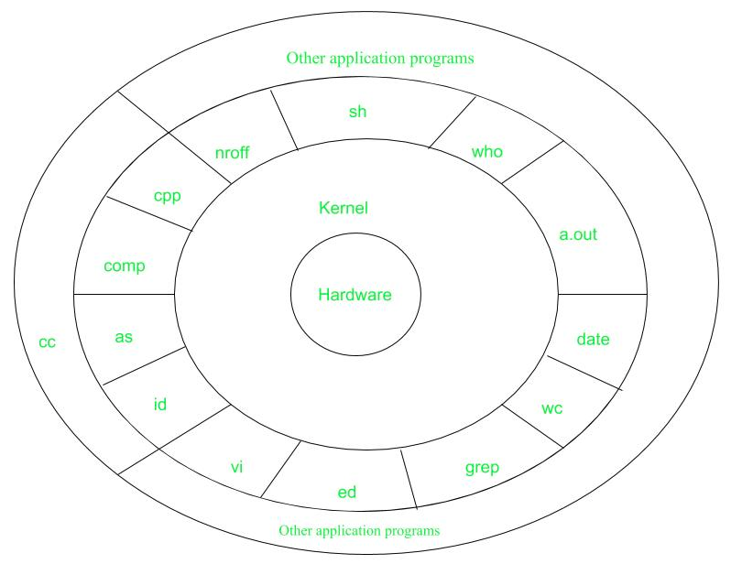

Reading Rainbow Tip: Find an image online that resembles the setting of this story, then replace the image above.

## What is Linux?

Just like Windows, iOS, and Mac OS, Linux is an operating system. In fact, one of the most popular platforms on the planet, Android, is powered by the Linux operating system. An operating system is a software that manages all of the hardware resources associated with your desktop or laptop.

To put it simply, the operating system manages the communication between your software and your hardware. Without the operating system (OS), the software wouldn’t function.

**The Linux operating system comprises several different pieces/concepts**:

1. **Bootloader –**  The software that manages the boot process of your computer. For most users, this will simply be a splash screen that pops up and eventually goes away to boot into the operating system.
2. **Kernel –** This is the one piece of the whole that is actually called?Linux?. The kernel is the core of the system and manages the CPU, memory, and peripheral devices. The kernel is the lowest level of the OS.
3. **Init system –** This is a sub-system that bootstraps the user space and is charged with controlling daemons. One of the most widely used init systems is the system? which also happens to be one of the most controversial. It is the init system that manages the boot process, once the initial booting is handed over from the bootloader (i.e., GRUB or GRand Unified Bootloader).
4. **Daemons –** These are background services (printing, sound, scheduling, etc.) that either start up during boot or after you log into the desktop.
5. **Graphical server –** This is the sub-system that displays the graphics on your monitor. It is commonly referred to as the X server or just X.
6. **Desktop environment –** This is the piece that the users actually interact with. There are many desktop environments to choose from (GNOME, Cinnamon, Mate, Pantheon, Enlightenment, KDE, Xfce, etc.). Each desktop environment includes built-in applications (such as file managers, configuration tools, web browsers, and games).
7. **Applications –** Desktop environments do not offer the full array of apps. Just like Windows and macOS, Linux offers thousands upon thousands of high-quality software titles that can be easily found and installed. Most modern Linux distributions (more on this below) include App Store-like tools that centralize and simplify application installation. For example, Ubuntu Linux has the Ubuntu Software Center (a rebrand of GNOME Software? Figure 1) which allows you to quickly search among the thousands of apps and install them from one centralized location.

## Why use Linux?

# This is the one question that most people ask. Why bother learning a completely different computing environment, when the operating system that ships with most desktops, laptops and servers work just fine?

# To answer that question, I would pose another question. Does that operating system you? re currently using really work? just fine?? Or, do you find yourself battling obstacles like viruses, malware, slowdowns, crashes, costly repairs, and licensing fees?

# If you struggle with the above, Linux might be the perfect platform for you. Linux has evolved into one of the most reliable computer ecosystems on the planet. Combine that reliability with zero cost of entry and you have the perfect solution for a desktop platform.

# That’s right, zero cost of entry… as in free. You can install Linux on as many computers as you like without paying a cent for software or server licensing.

# Let’s take a look at the cost of a Linux server in comparison to Windows Server 2016. The price of the Windows Server 2016 Standard edition is $882.00 USD (purchased directly from Microsoft). That doesn’t include Client Access License (CALs) and licenses for other software you may need to run (such as a database, a web server, mail server, etc.).

# For example, a single user CAL, for Windows Server 2016, costs $38.00. If you need to add 10 users, for example, that’s $388.00 more dollars for server software licensing. With the Linux server, it’s all free and easy to install. In fact, installing a full-blown web server (that includes a database server), is just a few clicks or commands away (take a look at ? Easy LAMP Server Installation? to get an idea of how simple it can be).

# If zero cost isn’t enough to win you over? what about having an operating system that will work, trouble-free, for as long as you use it? I’ve used Linux for nearly 20 years (as both a desktop and server platform) and have not had any issues with ransomware, malware, or viruses. Linux is generally far less vulnerable to such attacks. As for server reboots, they’re only necessary if the kernel is updated. It is not out of the ordinary for a Linux server to go years without being rebooted. If you follow the regular recommended updates, stability and dependability are practically assured.

## Open-source

# Linux is also distributed under an open-source license. Open source follows these key tenants:

# The freedom to run the program, for any purpose.

# The freedom to study how the program works, and change it to make it do what you wish.

# The freedom to redistribute copies so you can help your neighbor.

# The freedom to distribute copies of your modified versions to others.

# These points are crucial to understanding the community that works together to create the Linux platform. Without a doubt, Linux is an operating system that is ? by the people, for the people?. These tenants are also the main factor in why many people choose Linux. It’s about freedom and freedom of use and freedom of choice.

# 

# 

## What is a “distribution?”

Linux has a number of different versions to suit any type of user. From new users to hard-core users, you’ll find a “flavor” of Linux to match your needs. These versions are called distributions (or, in the short form, “distros”).

Nearly every distribution of Linux can be downloaded for free, burned onto disk (or USB thumb drive), and installed (on as many machines as you like).

Popular Linux distributions include:

* LINUX MINT
* MANJARO
* DEBIAN
* UBUNTU
* ANTERGOS
* SOLUS
* FEDORA
* ELEMENTARY OS
* OPENSUSE

Each distribution has a different take on the desktop. Some opt for very modern user interfaces (such as GNOME and Elementary OS’s Pantheon), whereas others stick with a more traditional desktop environment (openSUSE uses KDE).

You can check out the top 100 distributions on the [Distrowatch](https://distrowatch.com/).

And don’t think the server has been left behind. For this arena, you can turn to:

* Red Hat Enterprise Linux
* Ubuntu Server
* Centos
* SUSE Enterprise Linux

Some of the above server distributions are free (such as Ubuntu Server and CentOS) and some have an associated price (such as Red Hat Enterprise Linux and SUSE Enterprise Linux). Those with an associated price also include support.

# 

# Get Linux System and Hardware Details on the Command Line

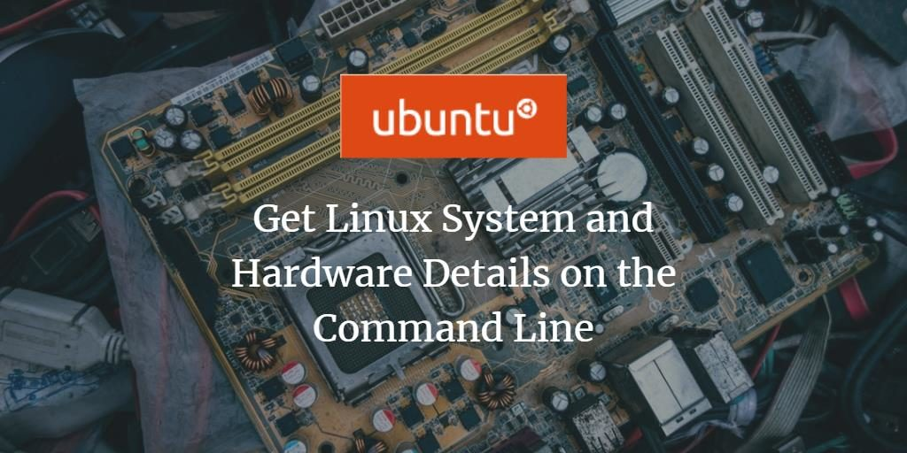

When using Linux, you may need to know details about the system you are running or the hardware specifications you are using. As a normal Linux user or software developer, it is important for you to check the compatibility of a software or hardware system you want to install. The Linux command line contains several built-in commands to help you become familiar with the software and hardware platform you are working on. This tutorial will teach you how to use all these commands to get the sysinfo Linux details.

The commands and examples mentioned in this tutorial have been tested on Ubuntu 20.04 and Debian 10.

## 

## 

### **CLI Commands**

## Some of the most common CLI commands that even a normal user can find useful in their work have been listed below:

| Command Name | Use | Example |
| --- | --- | --- |
| cd | Change directory to the directory specified with the command | cd Desktop/ |
| cd… | To move up one directory from the current directory | cd… |
| ls | List all the files and directories in the working directory | ls |
| mkdir | Create a new directory with the specified name inside the working directory | mkdir Personal |
| cp | Copy a file in the working directory to the specified directory | cp learning.txt Personal/ |
| clear | Clear the current CLI Window | clear |
| exit | Exit from the CLI window | exit |
| help | Get help regarding all the commands and their usage | Help |
| help | You can also specify the command for which the help is required to get a detailed description | help cd |

## 

## Note: All these commands are specific to Apple MAC OS. Their syntax may be different in other Operating System like Windows, but their function remains the same.

### 

### **Advantages and disadvantages of CLI**

## As with any other tool/technology in the world of computers, CLI also comes with its own advantages as well as some disadvantages.

#### **Advantages**

## Below are the advantages:

## If a user knows or can remember the commands, then the task can be performed very quickly as compared to a GUI.

## History of the last executed commands can be maintained for monitoring.

## Commands can be combined to create a script that can be run to perform a series of operations and can be scheduled

## so that it can run periodically without any further human efforts.

## A command run on CLI utilizes very less RAM memory and CPU cycle for completion.

## A CLI command can be deployed on a system remotely and executed without the knowledge of a user.

#### **Disadvantages**

## Below are the disadvantages:

## Remembering the exact syntax of the commands can be complicated. However, the modern-day CLI tools provide auto-completion to complete the basic commands in case the user forgets.

## It is not always evident what the command will do just by looking at a written command. Hence, no changes can be taken, and the user needs to ensure he knows the result of that command before executing.

## For a new user, getting used to CLI can be challenging and confusing.

## The user may need to learn a large number of commands to perform the tasks. However, people mostly remember only the commands that they frequently require in their work.

## 

## 

## 

## 

## Displaying Basic System Information on Linux Shell

To know the basic information about your system, you need to be familiar with the command-line utility called uname-short for unix name.

### The uname Command

The uname command comes with multiple switches. The basic command as described below only returns the Kernel name:

$ uname

**Output:**

**Result of uname command**

As you can see, the uname command when used without any switches only returns the kernel name i.e., Linux for my system.

### Get the Linux Kernel Name

When you precisely want the command to print the kernel name, you will use the following command:

$ uname -s

**Output:**

**Kernel name displayed with uname command**

The above output has displayed Linux as my kernel name.

### Get the Linux Kernel Release

$ uname -r

**Output:**

**Get Linux Kernel release information**

The above command has displayed the release number of my Linux

### Get the Linux Kernel Version

In order to fetch the version of your kernel, use the following command:

$ uname -v

**Output:**

**Linux Kernel version**

The above output shows the version number of my kernel.

### Get Network Node Hostname

You can use the following command to print the network hostname of your node:

$ uname -n

You can also use the following command for the same purpose as it is more user-friendly:

$ uname --nodename

**Output:**

**Get system hostname**

Both commands will display the same output. Please note that the hostname and the node name might not be the same for non-Linux systems.

### Get Machine Hardware Architecture (i386, x86\_64, sysinfo Linux)

In order to know the hardware architecture of the system you are working on, please use the following command:

$ uname --m

**Output:**

**Get Linux architecture x86_64**

The output x86\_64 signifies that I am using a 64-bit architecture. The output i686 means that a user is on a 32-bit system.

### Get Processor Type

In order to know the type of processor you are using, please use the following command:

$ uname -p

**Output:**

**Get Linux processor type**

This output shows that I am using a 64-bit processor.

### Get Hardware Platform

In order to know the hardware platform you are using, please use the following command:

$ uname -i

Get hardware platform information

In my case, the output is the same as that of the machine hardware name.

### Get Operating System information

The following command will let you know the name of the operating system you are using:

$ uname -o

**Output:**

**Linux Operating System information**

My Ubuntu machine has displayed the above output for my system.

### 

### 

### Displaying All Information of Uname Command

The above commands have displayed system information as per the type of switch used. In case, you want to see all the system information at once, use the following command:

$ uname -a

**Output:**

**uname -a result**

You can see that the above output shows the complete list of system information for the user.

## 

## 

## 

## 

## 

## 

## Displaying Detailed Hardware Information

Here we will describe the commands, other than uname, that are used to extract detailed hardware information of your system:

### Get Hardware Information with lshw

The lshw utility enables you to fetch important hardware information such as memory, CPU, disks, etc. from your system. Please run the following command as a super user in order to view this information:

$ sudo lshw

**Output:**

**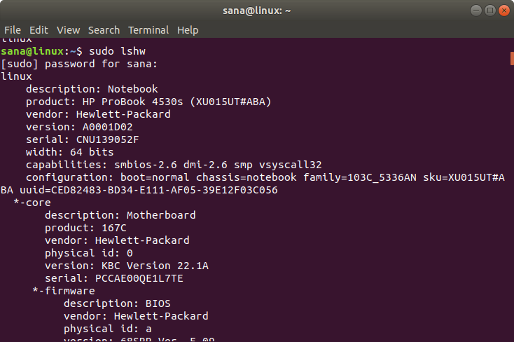**

The above output is a very detailed version of the hardware information of my system. You can also view a summary of hardware information as described in the following section.

#### 

#### 

#### 

#### 

#### Short Summary

In order to view the summary of your detailed hardware profile, please use the following command:

$ lshw -short

**Output:**

**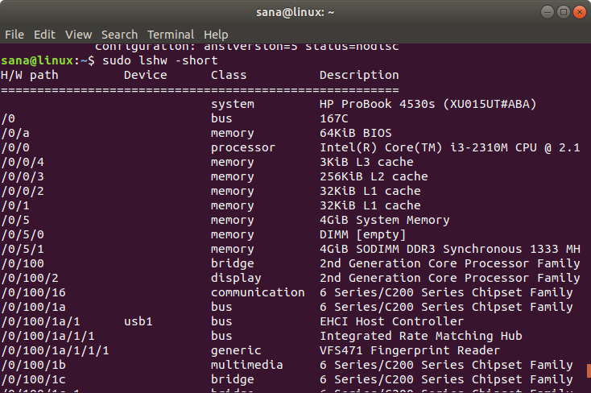**

The above output is a column-wise summary of the hardware profile which is more readable.

#### Creating an HTML File

The lshw utility also lets you print your hardware profile to an HTML file as a superuser. Use the following command for this purpose:

$ sudo lshw -html > [filename.html]

Example:

$ sudo lshw -html > hardwareinfo.html

**Output:**

**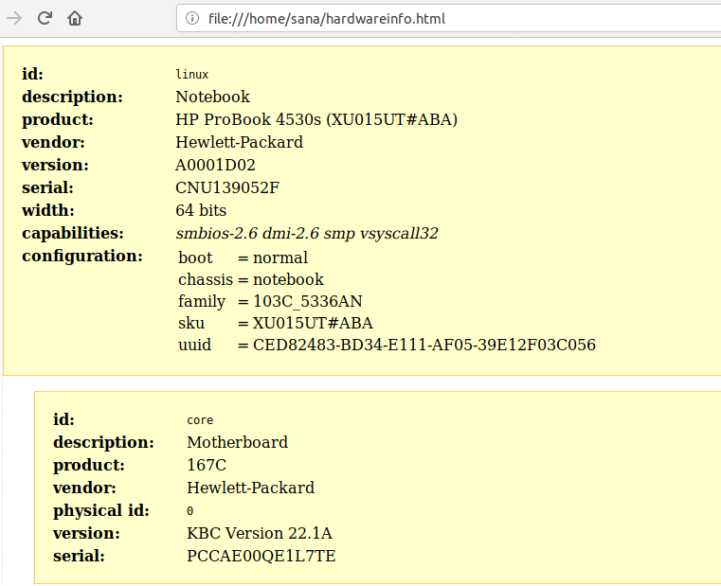**

The above HTML file has been created at the /home/user/ folder.

### 

### Get CPU Information with lscpu

The lscpu utility lists detailed CPU information from the files sysfs and /proc/cpuinfo to your screen. This is how you can use this command:

$ lscpu

**Output:**

**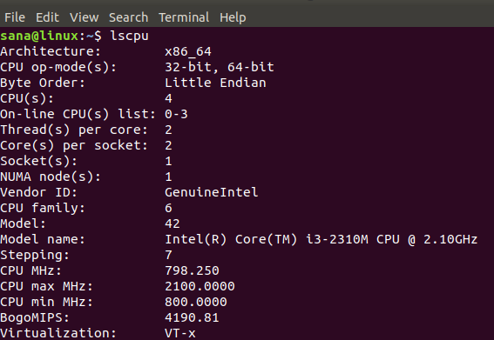**

The above output displays CPU architecture, number of CPUs, cores, CPU family model, threads, CPU caches and much more.

### Get Block Device Information with lsblk

The lsblk utility displays information about all the basic storage devices of your system such as hard drive, its partitions and the flash drives connected to your system.

$ lsblk

You can use the following command to view much more detailed information about all the devices:

$ lsblk -a

**Output:**

**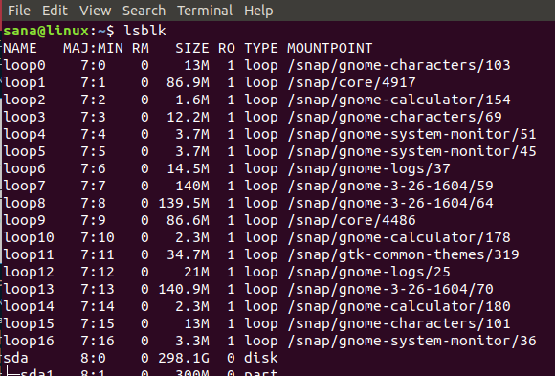**

### Get USB Device Information with lsusb

The lsusb command lists information about all the USB controllers and the devices connected to them. Please run the following command:

$ lsusb

You can also use the following command to view much detailed information about each USB device.

$ lsusb -v

**Output:**

**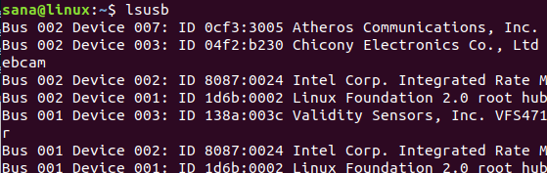**

This output displays all the USB controllers and the attached devices.

### 

### 

### 

### Get Information About Other Devices

You can also view information about the following devices of your system:

* PCI devices

Command: *$ lspci*

* SCSI devices

Command: *$ lsscsi*

* SATA devices

Command:

$ hdparm [devicelocation] e.g. $ hdparm /dev/sda2